INEURON HACKATHON - SQL SUBMISSIONS

1. select Month(e.HireDate) as "Month" , COUNT(e.BusinessEntityID) as "Count" from HumanResources.Employee as e, HumanResources.EmployeePayHistory as ep,HumanResources.Department as d,HumanResources.EmployeeDepartmentHistory as dp where e.BusinessEntityID=ep.BusinessEntityID and dp.BusinessEntityID=ep.BusinessEntityID and dp.DepartmentID=d.DepartmentID GROUP By Month(e.HireDate);

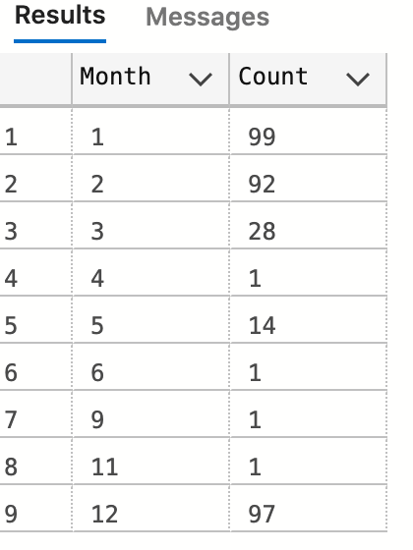

1. select d.Name as "Department Name" ,Year(e.HireDate) as "Year" , COUNT(e.BusinessEntityID) as "Number of Employees" from HumanResources.Employee as e, HumanResources.EmployeePayHistory as ep,HumanResources.Department as d,HumanResources.EmployeeDepartmentHistory as dp where e.BusinessEntityID=ep.BusinessEntityID and dp.BusinessEntityID=ep.BusinessEntityID and dp.DepartmentID=d.DepartmentID GROUP By Year(e.HireDate), d.Name ;

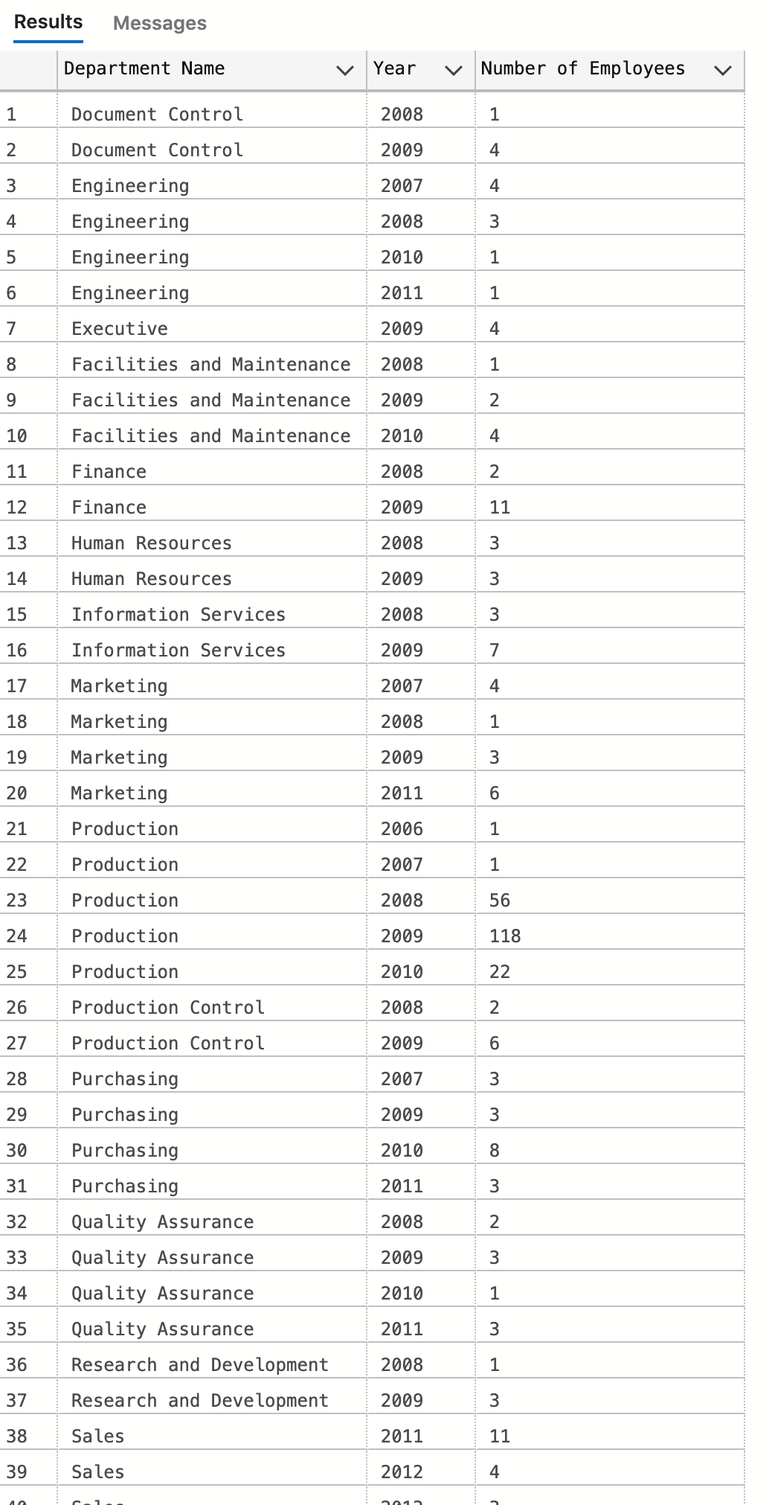

1. select distinct(p.FirstName), cr.Name as "Country" from Person.Person as p, Person.Address as a, Person.BusinessEntity as be, HumanResources.Employee as e, Person.AddressType as at,Person.BusinessEntityAddress as bea , Person.CountryRegion as cr, Person.StateProvince as sp where FirstName like 'S%' and p.BusinessEntityID <> e.BusinessEntityID and sp.CountryRegionCode=cr.CountryRegionCode and a.StateProvinceID= sp.StateProvinceID and bea.AddressID=a.AddressID and bea.BusinessEntityID=be.BusinessEntityID and bea.AddressTypeID=at.AddressTypeID and p.BusinessEntityID = be.BusinessEntityID;

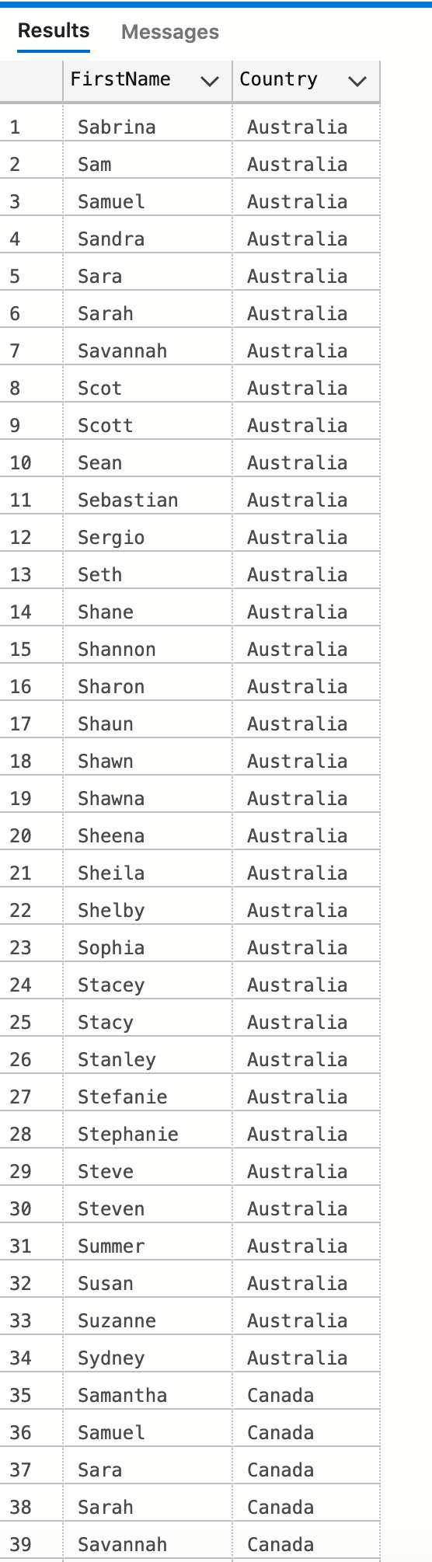

1. select e.OrganizationLevel ,COUNT(OrganizationLevel-1) as "Number ofEmployeesReporting" from HumanResources.Employee as e , Person.Person as p where e.BusinessEntityID=p.BusinessEntityID and OrganizationLevel is not NULL group by OrganizationLevel;

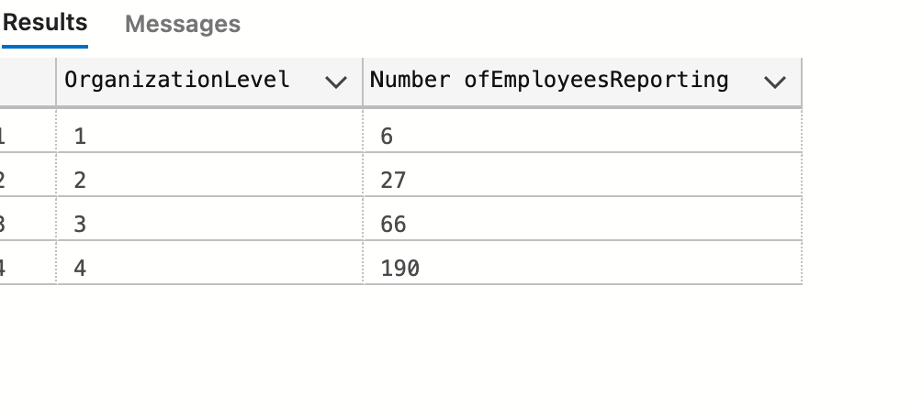

9. SELECT RANK() OVER(ORDER BY EndOfDayRate DESC)AS ranking ,crc.CountryRegionCode FROM Sales.CurrencyRate as cr, Sales.CountryRegionCurrency as crc, Sales.Currency as c where crc.CurrencyCode=c.CurrencyCode;

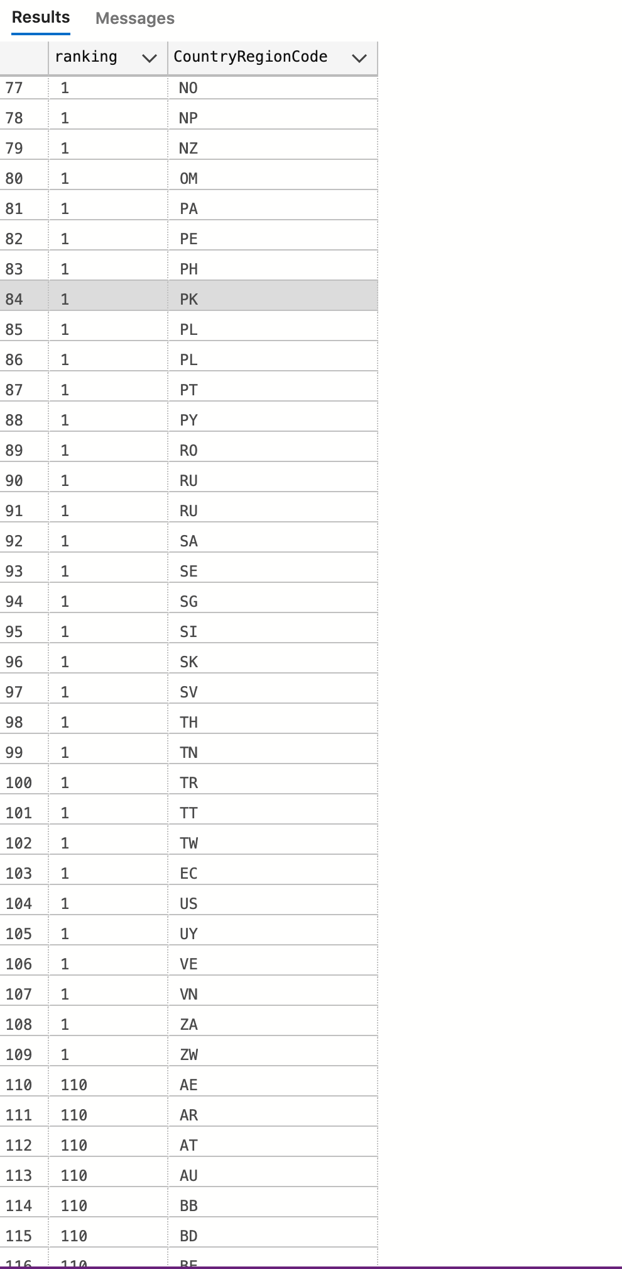

10.

select c.ProductID, MONTH(ss.OrderDate) as Month_Ordered, s.ExpMonth, s.ExpYear, YEAR(ss.OrderDate) as Year_Ordered, ss.*

from (Sales.SalesOrderHeader ss left join Sales.CreditCard s on ss.CreditCardID = s.CreditCardID) inner join Sales.SalesOrderDetail c on ss.SalesOrderID = c.SalesOrderID

where s.ExpMonth = MONTH(ss.OrderDate);

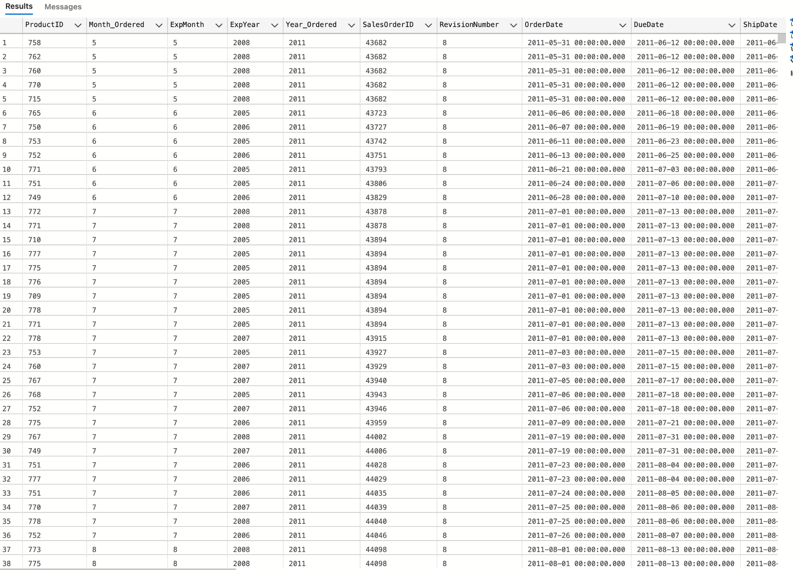

# If needed Same Year, the query goes as :

select c.ProductID, MONTH(ss.OrderDate) as Month_Ordered, s.ExpMonth, s.ExpYear, YEAR(ss.OrderDate) as Year_Ordered, ss.*

from (Sales.SalesOrderHeader ss left join Sales.CreditCard s on ss.CreditCardID = s.CreditCardID) inner join Sales.SalesOrderDetail c on ss.SalesOrderID = c.SalesOrderID

where s.ExpMonth = MONTH(ss.OrderDate) and s.ExpYear = YEAR(ss.OrderDate);

# results no columns..